Advisors
This section will provide details about the Advisor features build into the BUG mod. Here is a screenshot of the options screen:
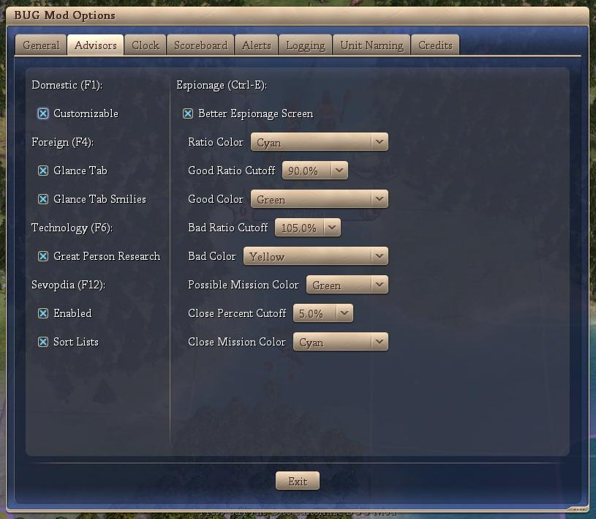
The individual Advisor features are discussed below:
- Domestic
If checked, then the built in Domestic Advisor is replaced with the Customizable Domestic Advisor (see below).
- Foreign
  - Glance Tab
If checked, the Glance tab is included
  - Glance Tab Smilies
If checked, the Glance tab includes Smilies similar to the scoreboard smilies
- Technology
  - Great Person Research
If checked, a row of great people followed by two techs are shown. The first of these two techs indicate the tech the great person would lightbulb. The second of these two techs indicates the tech the great person would lightbulb if the currently selected tech was known.
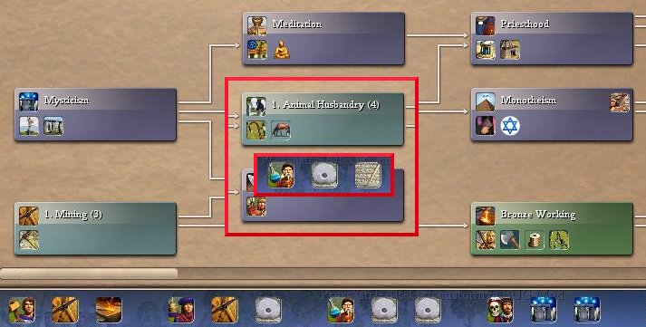
The above picture shows that a Great Scientist will lightbult roads and if you research mining, he will lightbulb roads. If, however, you research Animal Husbandry (insert), the Great Scientist will lightbulb writing.
- Sevopdia (see below)
  - Enabled
If checked, the in-game civopedia is replaced with the Servopdia.
  - Sort List
If checked, the lists are sorted.
- Espionage (Ctrl-E)
If checked, then the in-game Espionage advisor is replaced (see below).

Sevopedia
The following is from the initial post (edited for format) on the CFC forums regarding Sevopedia.

About SevoPedia
Greetings. I love cIV, but we all know that they dropped the ball with the civilopedia. It's impossible to navigate easily and non-intuitive in design. So this is an improvement. Sevo's Civilopedia (or...Sevo-lo-pedia, or even Sevopedia, but I digress...) This mod turns the civilopedia into a nicer, user-friendly, easy-to-navigate reference.
Features
    - Menus moved to left, with main menu on far left, sub-menu next to it
    - Main menu list reordered into groups with icons
    - Sub Menu organized into an easy to read list.
    - New in this version: Pictures included in list!
    - No more hopping away from the top screen when you select a page. The page comes up in the available to space on the right
    - Includes previously hidden entries (check out the barbarian leader...)
    - Will easily integrate with almost all existing mods
    - Can disable animations if desired
    - Vovan's Unit Upgrade Chart: Will automatically produce upgrade chart for units, even when modded!
From the above, the intention is to just reorganize the content of the civilopedia and thus it would appear that there is no spoilerish information provided. Discussion about what is in the CDA and why it isn’t spoilerish.
I’ve included a sample screenshot of the default civilopedia (top picture) and the corresponding item from the sevopedia (bottom picture).
It would appear that the Sevopedia is just a reorganization of the menu and the inclusion of the actual data page with the index to the left.
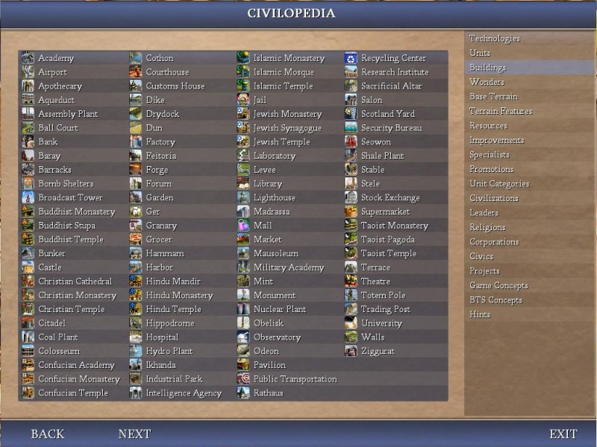
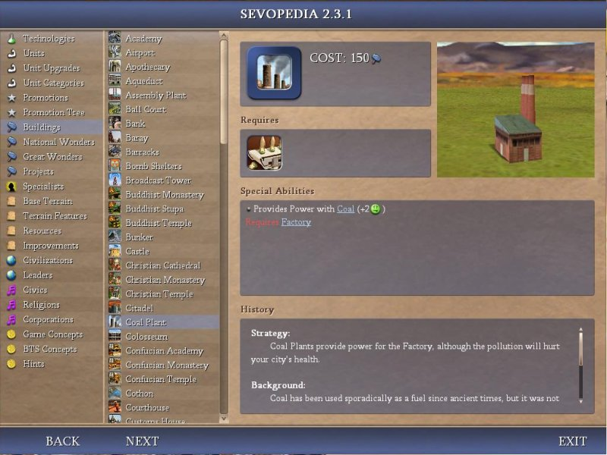
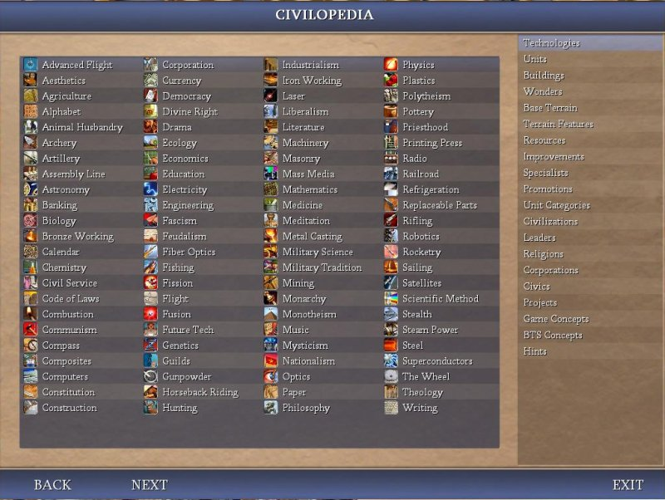
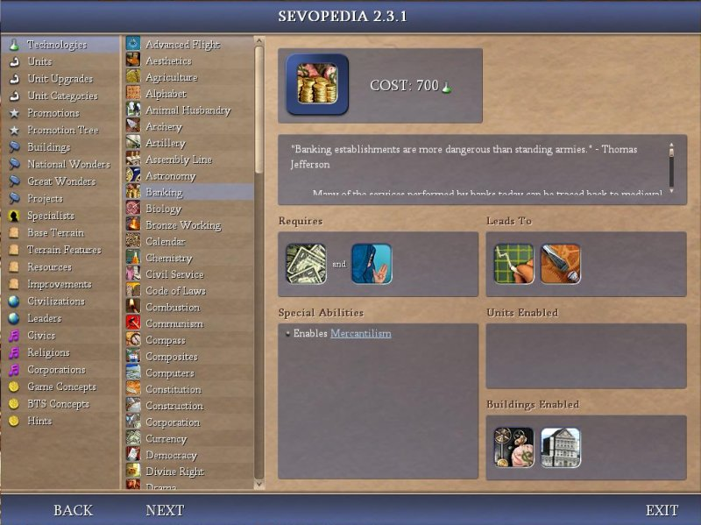
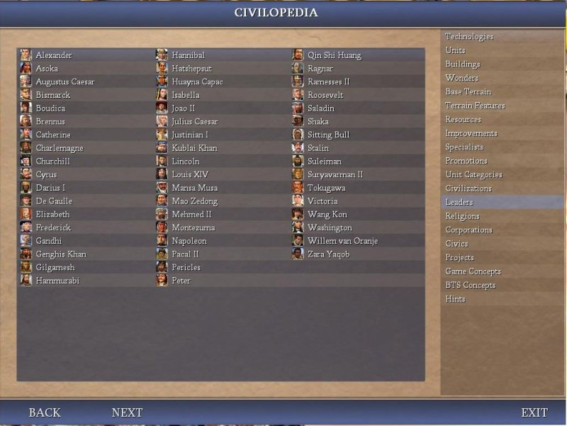
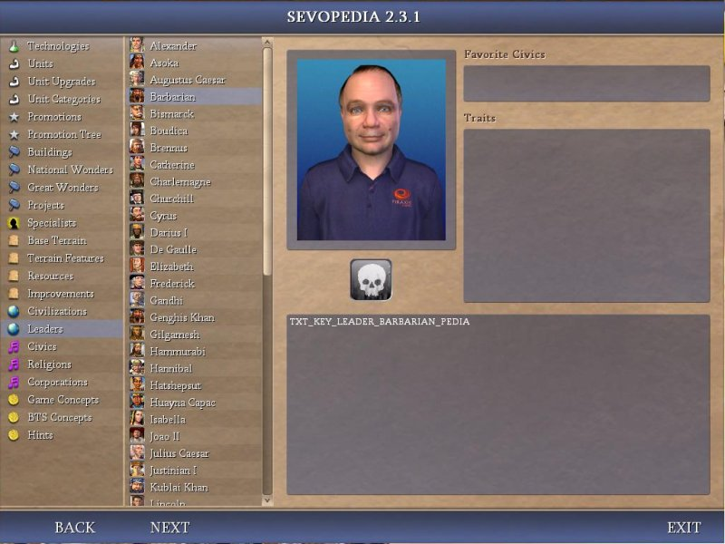

Customizable Domestic Advisor
The Customizable Domestic Advisor has a default view that the user can modify. There are an unlimited number of pages that the user can add to the advisor. The following is a list of the columns that the user can add.
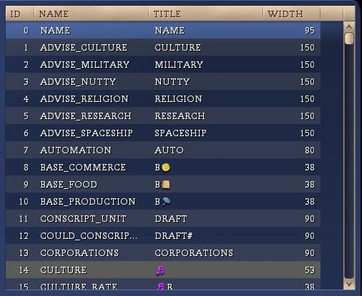
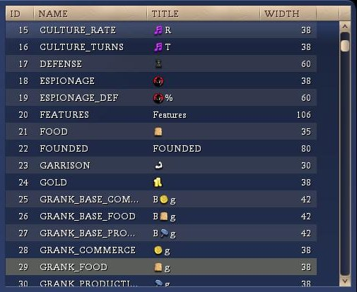
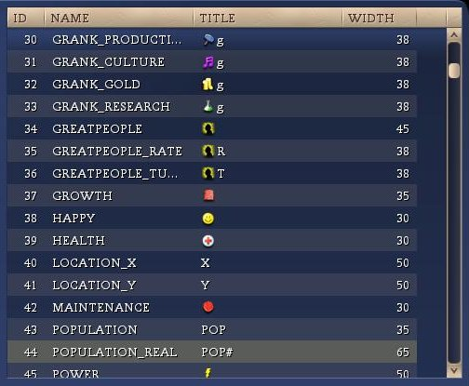
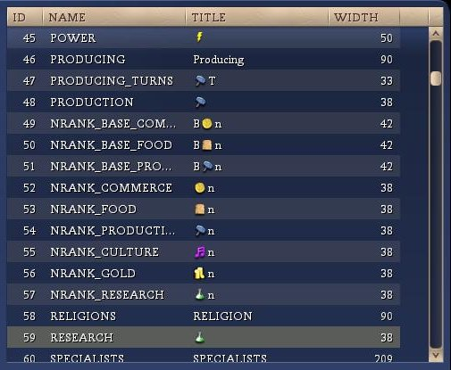
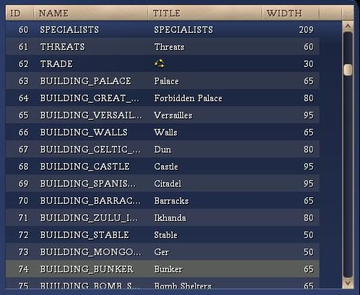
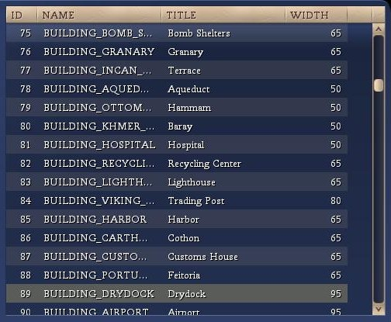
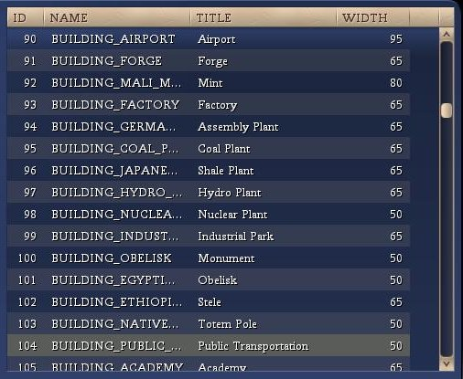
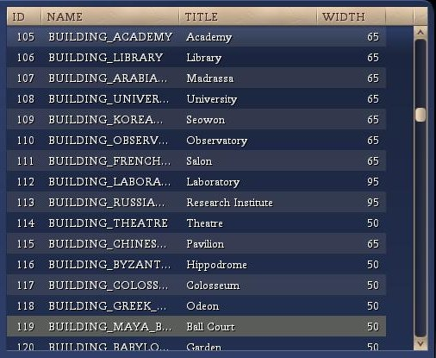
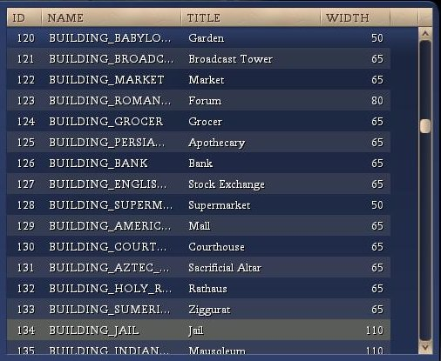
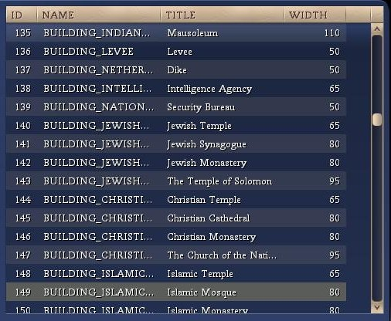
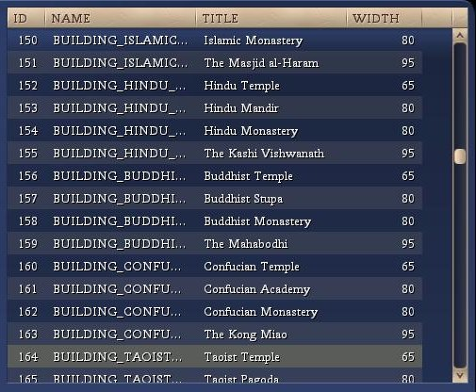
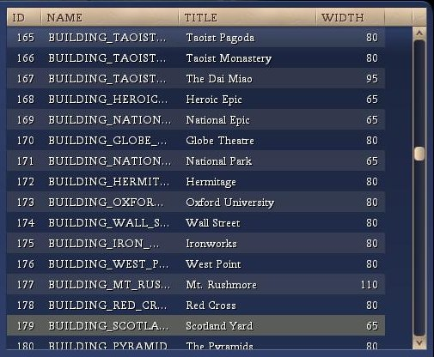
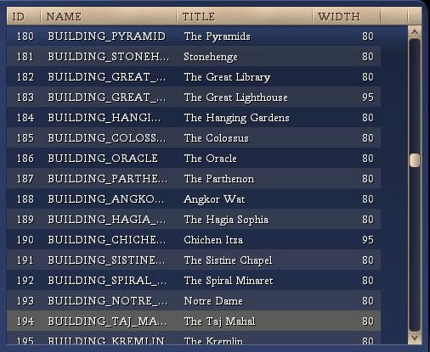
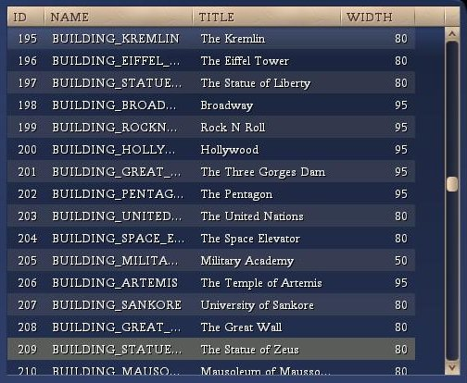
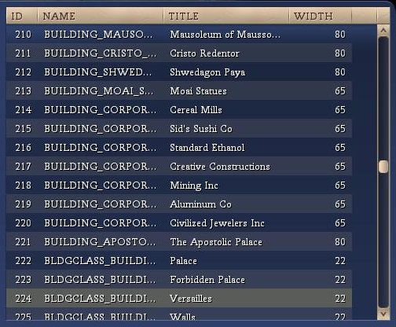
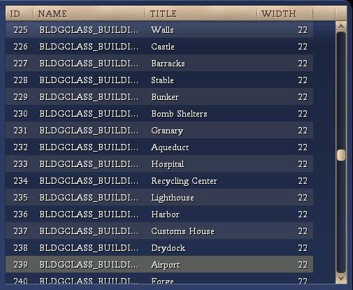
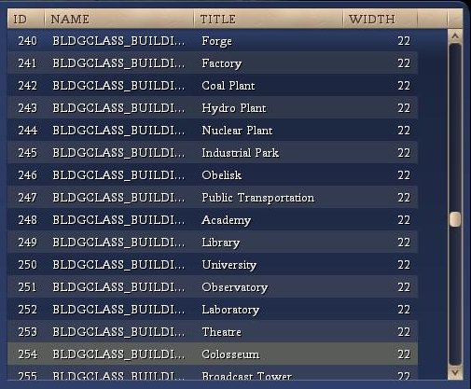
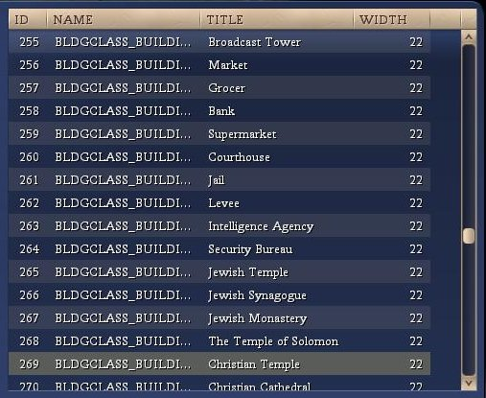
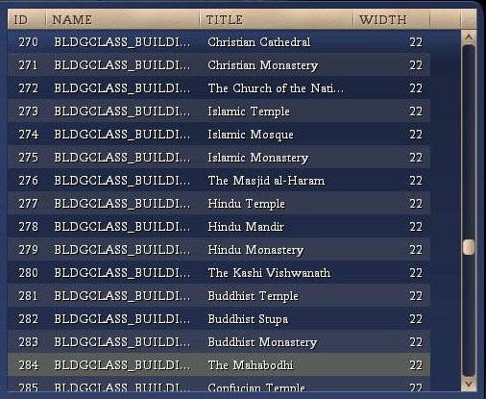
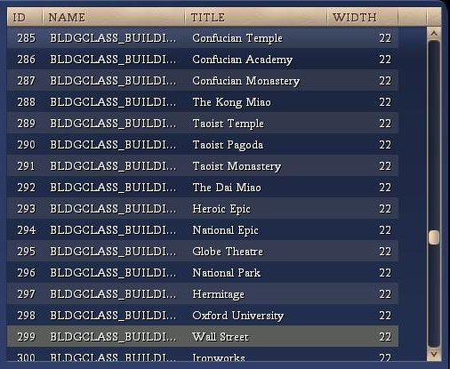
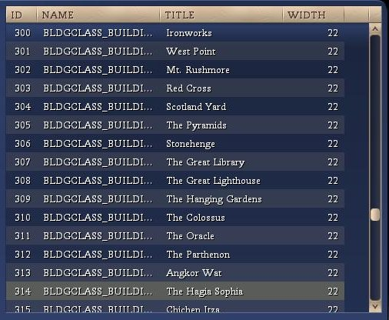
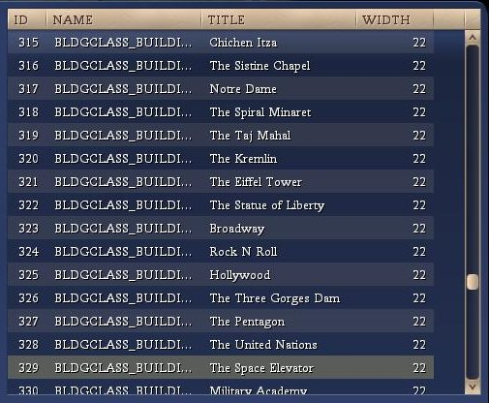
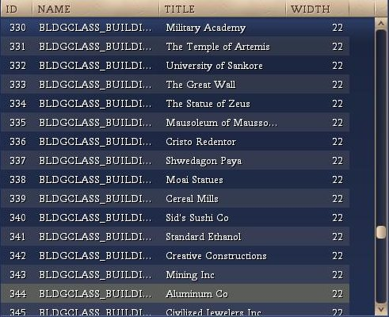
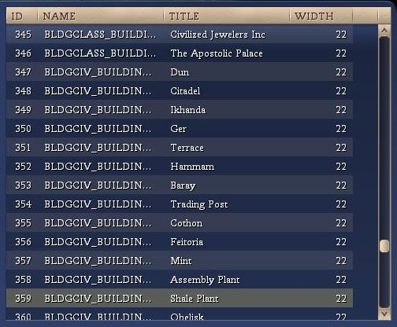
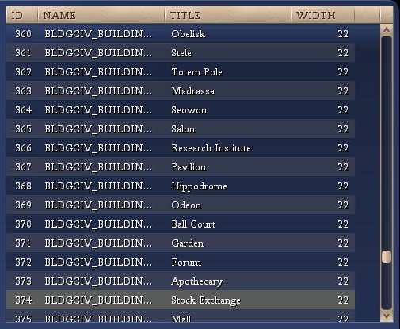
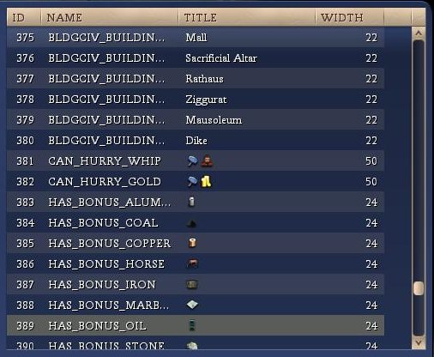
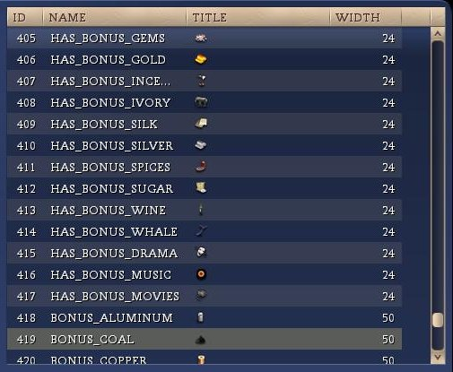
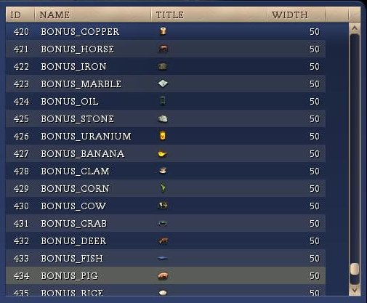
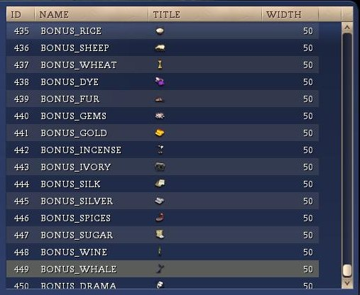
After review, the list of items does not contain spoiler information apart from the GRANK_* items. Those columns return the city’s rank on various items as measured against all other cities (known and unknown).

Discussion about what is in the CDA and why it isn’t spoilerish.
Pic of default version
Pic of BUG version

BUG Espionage Advisor
Discussion about what is in the BUG Espionage Advisor and why it isn’t spoilerish.
Pic of default version
Pic of BUG version

Conclusion
Opinion: It is our opinion that no additional information is presented to the user via this section of the BUG mod and it should be approved.

If you ignore the inclusion of the barbarian leader which doesn’t seem like a very big deal.

